RADM (Ret) George Yount

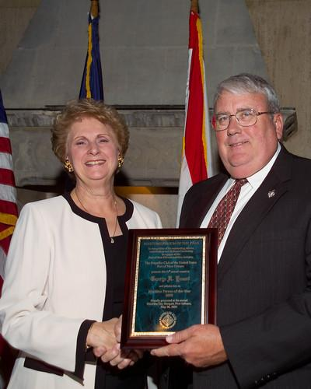
George Yount retired from the U.S. Navy as Deputy Commander for Ship Design Integration and Engineering, Naval Sea Systems Command, in 2001. He is now the Sector Vice president of Ship Construction for Northrop Grumman Corporation providing oversight of operations in Avondale and Pascagoula. Most recently LPD-17 has been delivered by Northrop Grumman and Hurricane Katrina received by Northrop Grumman. An evening with George Yount promises to be an interesting one.

Northrop Grumman's Ship Systems sector (NGSS), headquartered in Pascagoula, Mississippi, includes primary operations in Pascagoula, Miss., New Orleans, La., Gulfport, Miss., and Tallulah, La., as well as in fleet support offices in the U.S. and Japan. NGSS, which currently employs more than 18,000 shipbuilding professionals, is one of the nation's leading full service systems companies for the design, engineering, construction, and life cycle support of major surface ships for the U.S. Navy, U.S. Coast Guard and international navies, and for commercial vessels of all types.
George R. Yount, sector vice president of ship construction for Northrop Grumman's Ship Systems sector, was honored by the U.S. Port of New Orleans Propeller Club as the 2006 Maritime Person of the Year. Jacqueline K. Tonguis, club president, presented the award to Yount. Given annually, the award is presented to a person who has demonstrated outstanding leadership in furthering and promoting the maritime industry. Yount is the 47th Maritime Person of the Year for this organization.

Photo Courtesy: Northrop Grumman Ship Systems

George Yount was commissioned into the Navy following graduation from the University of Wisconsin, Stout, with a degree in industrial education. He later received a master's degree in mechanical engineering from the Naval Postgraduate School. He received the 1996 Distinguished Alumni award from University of Wisconsin, Stout, is a member of Sigma Xi, and a life member of the American Society of Naval Engineers. His military awards include the Navy Distinguished Service Medal, Legion of Merit with two gold stars, Meritorious Service Medal with four gold stars, Navy Commendation Medal with three gold stars, and Combat V.

His naval career included service on both surface ships and submarines with operational assignments on four ships. More than 25 years of his career was spent as a naval engineer with assignments in five different shipyards and two repair activities.

